Work Instruction

Entering Right to Work, Disclosure and Registration Checks into iTrent
A process for entering all Right to Work/Registration and Visa (Time Limited Right to Work) checks into the iTrent HR System

Document Ref:
Version: | V1
Issue Date: | 05/10/22
Status: | In progress
Produced by: | Marnie Cunningham
Contact details:
Test / Passed

Contents
1 Checklist 3
2a Step by Step Procedure – Right to Work, Disclosure and Registration Checks 4

2b Step by Step Procedure - Time Limited Right to Work (Visa) details 9

Activity Overview
Summarize:
- All right to work, disclosure, registration and time limited right to work (Visa) checks to be entered into the iTrent HR system.
- Information to be added to the system as set out below and in MHA Policy HR4.15 Right to Work in the UK.
- Evidence of the check to be uploaded as an attachment.
- To be maintained by the site.

Systems to be used
iTrent
Version Control
Issue No: | Issue Date: | Issue Author: | Reason for Issue Update:

Checklist

Task to be completed | Complete?
Make sure that all relevant Right to Work, Registration, Disclosure and time
limited Right to Work (Visa) checks have been completed prior to the
employee starting work.

Enter all details into the system by following the Work Instructions.
Upload all evidence into the system as an attachment.

Step by Step Procedure

2a Right to Work, Disclosure and Registration Checks

- Log into mhapeople and select Employee Information:

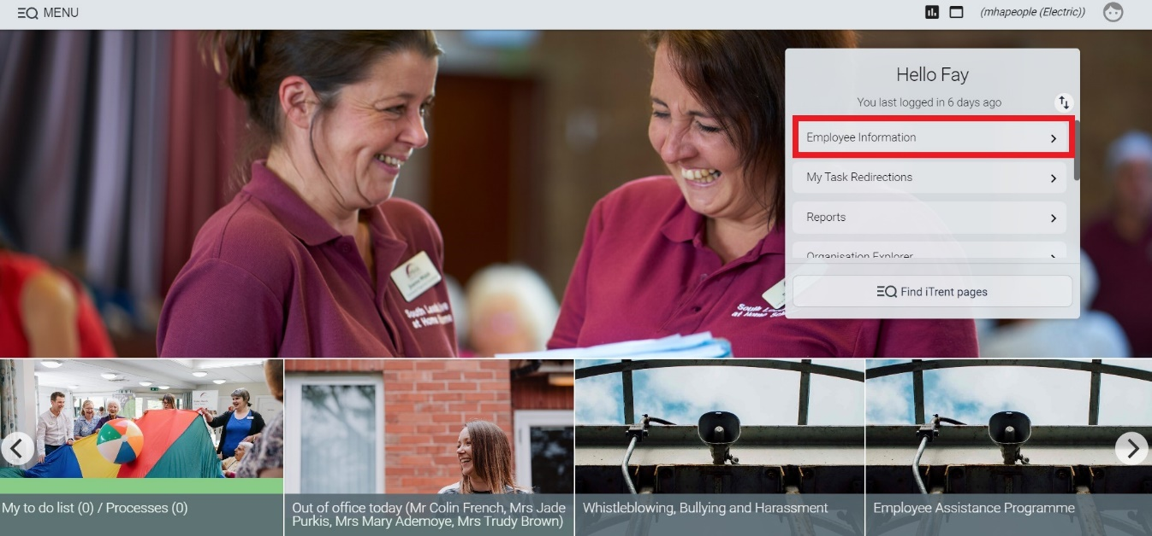

- Select the name of the employee you will be entering details against.

- Select ‘Check Details (DBS, NMC PIN etc)’ to enter the employee’s Right to Work Checks, Disclosure and Registration:

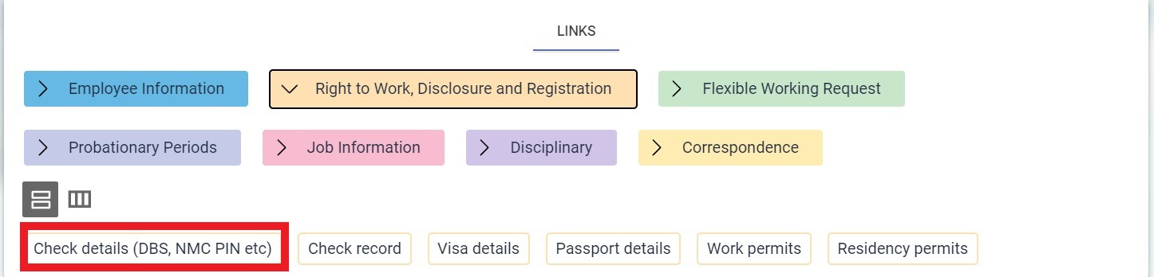

- Select the type of check or registration you are entering from the drop-down box. Please ensure that you select the correct option for the check or registration you are evidencing:

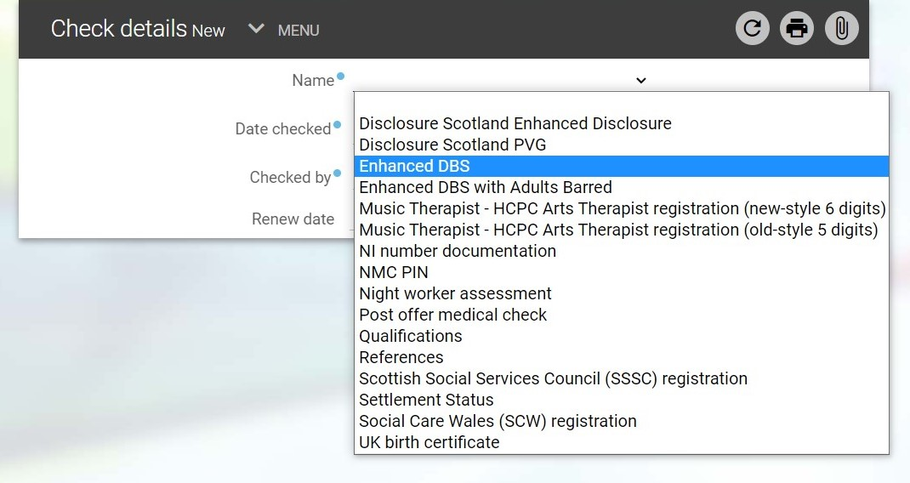

- For disclosures, please select the type of disclosure in the ‘Name’ section, and in the ‘Check method’ drop down select either ‘Written Application’ or ‘Online’. ‘Written Application’ should be selected for standard Care Check requests and ‘Online’ for the DBS Update Service (i.e. Portable DBS).

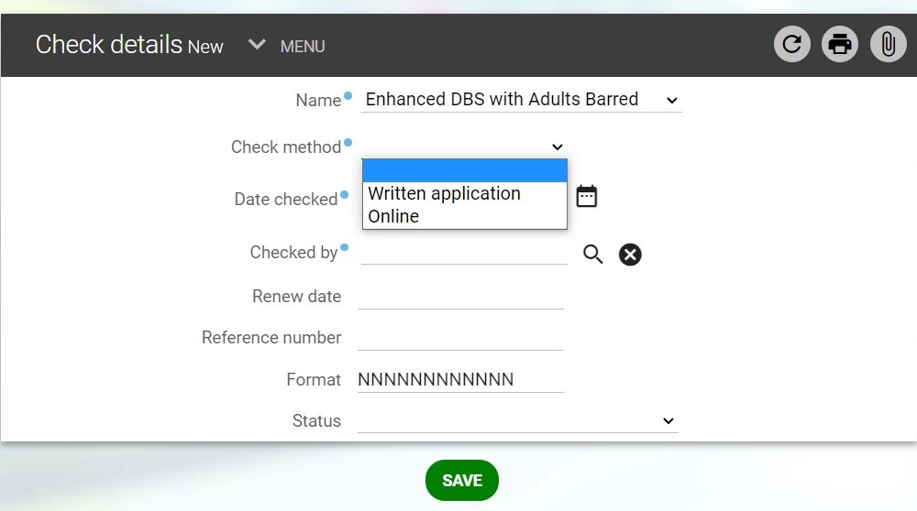

If you select ‘Written application’ you will need to select ‘Completed’ in the ‘Check Progress’ box:

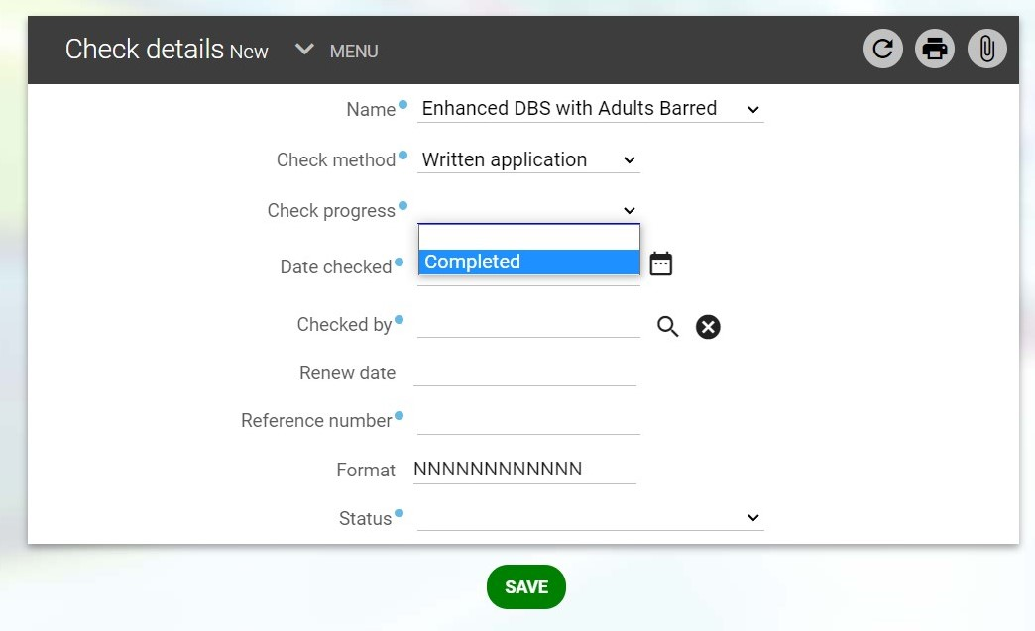

- Enter the date that the check was completed in the ‘Date Checked/Date consent given’ field. Please ensure the date entered is the date featured on the certificate/check. The ‘Renew date’ field will auto populate.

- The ‘Checked by’ field will auto populate with the name of the person logged in to mhapeople. (NB If you are uploading a historic check and did not complete this originally, you will be able to add the details of the person who completed the original check in the ‘Notes’ section after you have completed the page and saved it. Please see section 11 for details of how to do this)

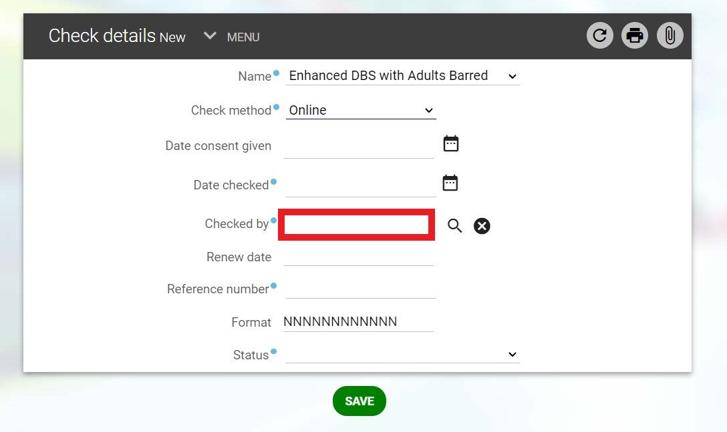

- Enter the reference number in the ‘Reference number’ field.

- Select the status from the drop-down menu as appropriate:

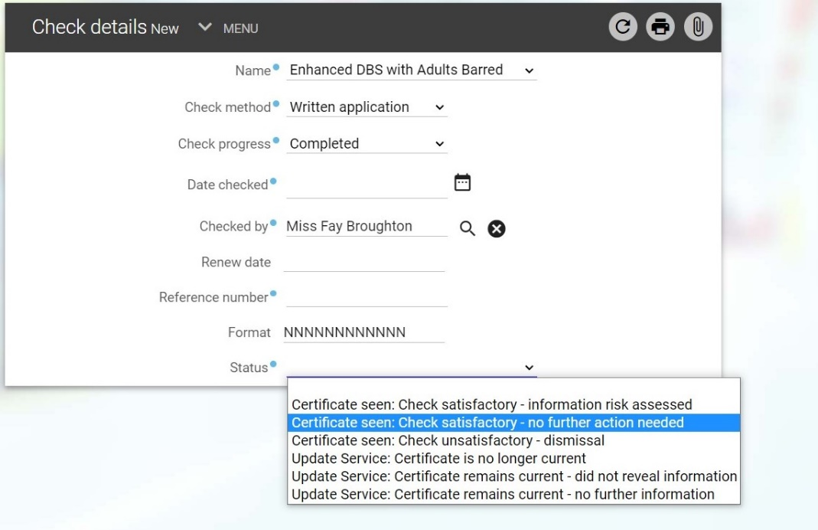

- When the page is complete, press save:

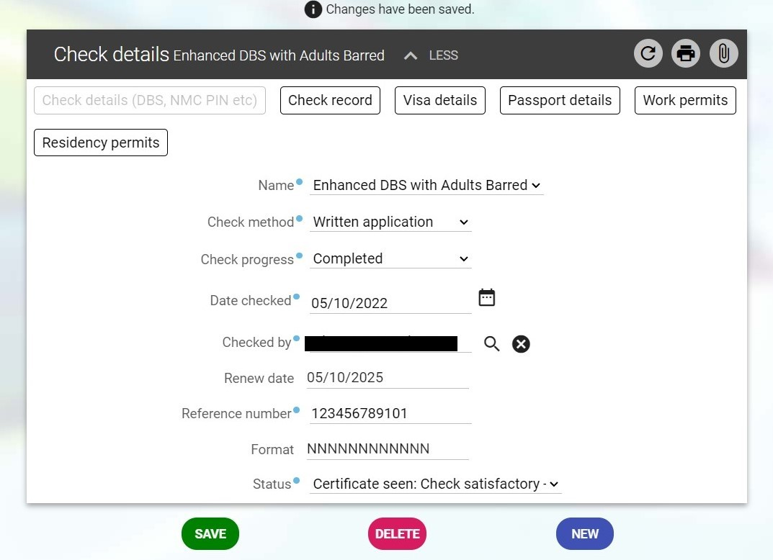

- Add your evidence as attachments by selecting the paperclip in the top right corner of the page:

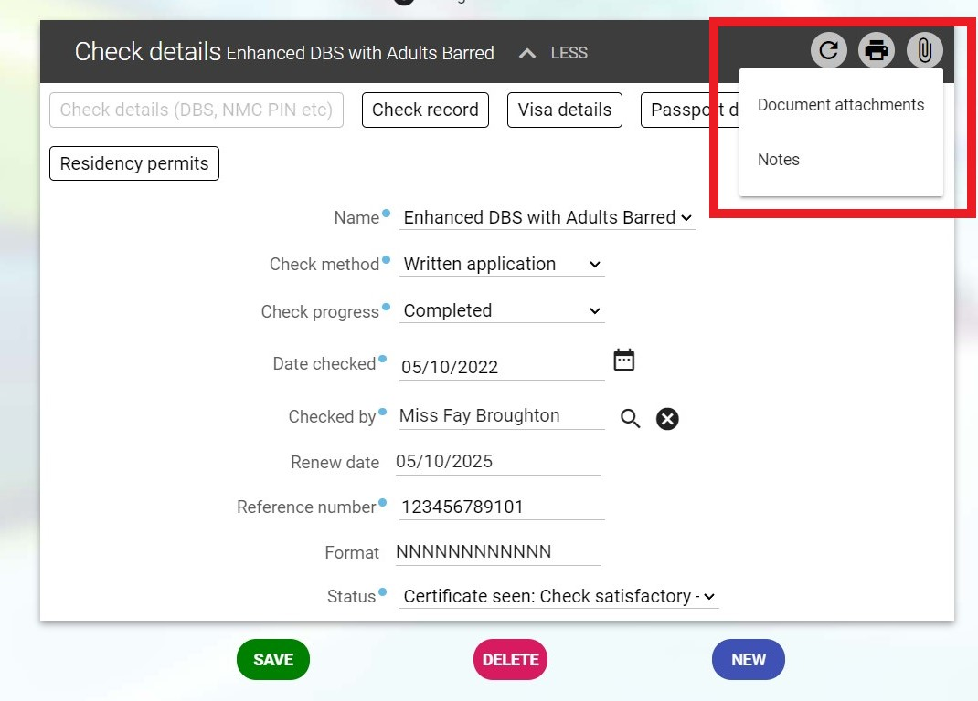

If you need to add further checks, select ‘new’.

You can also add notes if you wish. If this check is being entered by you but you didn’t complete the original check, you can document this in the ‘Notes’ section at this point e.g. Name of the person who completed the check, their job role (if stated) and the date this was done.

- Each check from the drop-down list will require you to enter the details listed on the page. You will also be expected to upload the relevant evidence as an attachment.

2b Time Limited Right to Work (Visa) details including Positive Verification Notice (PVN)

- Select the Visa Details button from the Employee Information screen:

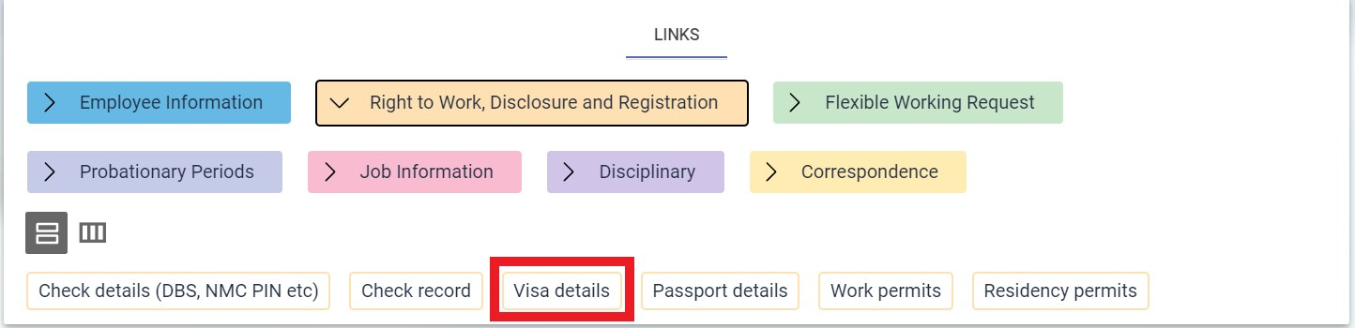

- Enter the Visa details as below, the Visa/PVN expiry date field is mandatory. If the employee has indefinite right to remain, please enter this date as 01/01/2099:

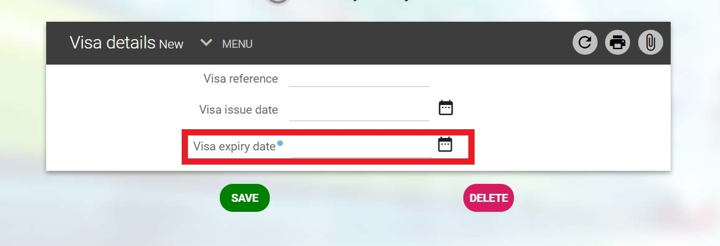

- Save the page, and upload the evidence of the Visa/PVN as an attachment by selecting the paperclip in the top right corner of the page:

